Name: Nakshatra Garde
Assignment: MyNalanda Assignment
_______________________________________________________________________________________
- R studio Code
library(shiny)
library(dplyr)
library(plotly)
library(readxl)
library(shinyWidgets)
# ================= LOAD DATA =================
teachers <- read_excel("teachers_master.xlsx")
late_data <- read_excel("late_records.xlsx")
attrition <- read_excel("attrition_data.xlsx")

colnames(teachers) <- make.names(colnames(teachers))
colnames(attrition) <- make.names(colnames(attrition))
colnames(late_data) <- make.names(colnames(late_data))

ui <- uiOutput("app_page")

server <- function(input, output, session){

logged_in <- reactiveVal(FALSE)
current_tab <- reactiveVal("dashboard")

# ================= LOGIN UI =================
login_ui <- fluidPage(

tags$head(
tags$style(HTML("
body {
margin: 0;
padding: 0;
background-color: #0f1b2b;
font-family: 'Segoe UI', sans-serif;
}

.main-container { display: flex; height: 100vh; }

.left-panel {
flex: 1;
position: relative;
background:
linear-gradient(to right,
rgba(10,20,35,0.65) 0%,
rgba(10,20,35,0.55) 40%,
rgba(10,20,35,0.85) 100%
),
url('https://encrypted-tbn0.gstatic.com/images?q=tbn:ANd9GcQG48O1XHX4TeW2o0ftRmBXVB6RXzT0HP75bQ&s') no-repeat center;
background-size: 85%;
background-position: center;
}

.school-name {
position: absolute;
bottom: 20px;
left: 30px;
color: white;
font-size: 22px;
}

.right-panel {
flex: 1;
background: linear-gradient(135deg, #0f1b2b, #16263d);
display: flex;
justify-content: center;
align-items: center;
}

.login-card {
width: 380px;
background: #0b1624;
padding: 45px;
border-radius: 18px;
text-align: center;
color: white;
box-shadow: 0 0 25px rgba(138, 43, 226, 0.6),
0 0 60px rgba(138, 43, 226, 0.4);
}

.btn-login {
width: 100%;
background: #00bcd4;
border: none;
padding: 10px;
border-radius: 5px;
color: white;
font-weight: bold;
}
"))
),

div(class = "main-container",
div(class = "left-panel",
div(class = "school-name", "Ideal International School"),

),
div(class = "right-panel",
div(class = "login-card", tags$a(href='https://google.com',
tags$img(src = "mynalanda.png", width = "120px", style = "margin-bottom:20px;display:block; margin-left:auto; margin-right:auto;")),
h4("myNalanda Solutions & Services Pvt. Ltd."),
textInput("username", "Username"),
passwordInput("password", "Password"),
selectInput("role", "Login As",
choices = c("","Teacher", "Admin", "Student")),
actionButton("login", "Login", class = "btn-login",color="#000814"),

)
)
)
)

# ================= DASHBOARD UI =================
dashboard_ui <- fluidPage(

tags$head(
tags$style(HTML("
body { margin:0; background-color:#1f2a33;
font-family:'Segoe UI', sans-serif; color:#00e5ff;}

.main-layout{ display:flex; height:100vh; }
.sidebar{
width:230px;
background-color:#18232b;
padding:20px;
color:white;
}
.content{
flex:1;
padding:20px 40px;
overflow-y:auto;
}
.menu{ cursor:pointer; padding:6px 0; }
.menu:hover{ color:#00e5ff; }

.info-row{
display:flex;
justify-content:space-between;
font-size:14px;
margin-bottom:30px;
color:#4fc3f7;
}
.kpi-row{
display:flex;
justify-content:space-between;
margin-bottom:40px;
}
.kpi-circle{
width:140px;
height:140px;
border-radius:50%;
border:2px solid #00e5ff;
display:flex;
flex-direction:column;
justify-content:center;
align-items:center;
color:#00e5ff;
box-shadow:0 0 20px rgba(0,229,255,0.3);
}
.kpi-value{ font-size:28px; font-weight:bold; }
.kpi-label{ font-size:12px; text-align:center; color:white; }

.performance-box{
background:#102027;
padding:15px;
border-top:6px solid #00bcd4;
}

.teacher-box {
background:#0b113d;
padding:20px;
border-radius:10px;
border:1px solid #7b2cbf;
box-shadow:0 0 15px #7b2cbf;
margin-bottom:20px;
color:white;
}

.profile-circle {
width:180px;
height:180px;
border-radius:50%;
margin:auto;
background:black;
box-shadow:0 0 40px #00e5ff;
}
"))
),

div(class="main-layout",

# Sidebar
div(class="sidebar",
h4("Ideal International"),
div(class="menu",
onclick="Shiny.setInputValue('nav','dashboard',{priority:'event'})",
"Dashboard"),
div(class="menu",
onclick="Shiny.setInputValue('nav','teacher',{priority:'event'})",
"Teacher"),
div(class="menu",
onclick="Shiny.setInputValue('nav','attrition',{priority:'event'})",
"Late Count & Attrition"),
br(),
actionButton("logout","Logout",
style="background:#00bcd4;color:white;width:100%;")
),

# Content
div(class="content",
uiOutput("page_content")
)
)
)
# ================= LOGIN LOGIC =================
observeEvent(input$login,{
if(input$username=="admin" && input$password=="1234"){
logged_in(TRUE)
} else {
showModal(modalDialog("Invalid credentials"))
}
})

observeEvent(input$logout,{
logged_in(FALSE)
current_tab("dashboard")
})

observeEvent(input$nav, {
current_tab(input$nav)
})

output$app_page <- renderUI({
if(!logged_in()) login_ui else dashboard_ui
})

# ================= GAUGE FUNCTION =================
create_gauge <- function(value, max_value, label, suffix=""){

plot_ly(
type = "indicator",
mode = "gauge+number",
value = value,

number = list(
suffix = suffix,
font = list(size=22, color="#00e5ff")
),

title = list(
text = label,
font = list(size=14, color="#00e5ff")
),

gauge = list(
axis = list(range = list(0, max_value)),
bar = list(color="#00e5ff"),
bgcolor = "#1f2a33",
borderwidth = 1,
bordercolor = "#00e5ff"
)
) %>%
layout(
paper_bgcolor="#1f2a33",
plot_bgcolor="#1f2a33",
font=list(color="#00e5ff")
)
}

# ================= PAGE CONTENT =================
output$page_content <- renderUI({

# ================= DASHBOARD TAB =================
if(current_tab()=="dashboard"){

total_teachers <- nrow(teachers)

high_risk <- if("Risk_Level" %in% colnames(attrition)){
nrow(dplyr::filter(attrition, Risk_Level=="High"))
} else { 0 }

total_late <- if("Late_Count" %in% colnames(late_data)){
sum(late_data$Late_Count, na.rm = TRUE)
} else { 0 }

overall_score <- if("Overall_Score" %in% colnames(teachers)){
round(mean(teachers$Overall_Score, na.rm=TRUE),1)
} else { 0 }

tagList(

fluidRow(
column(3, h4(paste("Total Teachers:", total_teachers))),
column(3, h4(paste("High Risk:", high_risk))),
column(3, h4(paste("Total Late Count:", total_late))),
column(3, h4(paste("Avg Overall Score:", overall_score,"%")))
),

br(),

fluidRow(
column(3, plotlyOutput("g1")),
column(3, plotlyOutput("g2")),
column(3, plotlyOutput("g3")),
column(3, plotlyOutput("g4"))
),

br(),

fluidRow(
column(12, plotlyOutput("area_chart", height="400px"))
)
)
}

# ================= TEACHER TAB =================
else if(current_tab()=="teacher"){

teacher_choices <- teachers$Teacher_Name

tagList(

selectInput("teacher_select","Teacher Name",
choices = teacher_choices),

br(),

uiOutput("teacher_full_ui")
)
}

# ================= ATTRITION TAB =================
else if(current_tab()=="attrition"){

teacher_choices <- if("Teacher_Name" %in% colnames(teachers)){
teachers$Teacher_Name
} else { NULL }

tagList(
selectInput("late_teacher","Select Teacher",
choices = teacher_choices),
br(),
plotlyOutput("late_trend"),
br(),
selectInput("risk_filter","Filter Risk Level",
choices=c("All","High","Medium","Low")),
tableOutput("attr_table")
)
}
})
output$teacher_full_ui <- renderUI({

req(input$teacher_select)

teacher_data <- teachers %>%
dplyr::filter(Teacher_Name == input$teacher_select)

req(nrow(teacher_data) > 0)

# ================= LATE CALC =================
late_current <- late_data %>%
dplyr::filter(Teacher_ID == teacher_data$Teacher_ID,
Month == max(Month)) %>%
dplyr::summarise(total = sum(Late_Count, na.rm=TRUE)) %>%
dplyr::pull(total)

if(length(late_current)==0) late_current <- 0

# ================= LEAVE CALC =================
unplanned_leave <- if("Unplanned_Leaves" %in% colnames(teacher_data)){
teacher_data$Unplanned_Leaves
} else { 0 }

leave_balance <- if("Leave_Balance" %in% colnames(teacher_data)){
teacher_data$Leave_Balance
} else { 0 }

# ================= SCORES =================
int_score <- teacher_data$Int_BM_Score
ext_score <- teacher_data$Ext_BM_Score
compliance <- teacher_data$Compliance_Score
cca <- teacher_data$CCA_Score
overall <- teacher_data$Overall_Score

fluidPage(

fluidRow(

column(4,
div(style="background:#0b113d;padding:15px;border-radius:10px;border:1px solid #7b2cbf;color:white;",
h4("Teacher Overview"),
h5(paste("Late (Current Month):", late_current)),
h5(paste("Unplanned Leaves:", unplanned_leave)),
br(),
h5("Leave Balance"),
div(style="display:flex;gap:5px;",
lapply(1:12, function(i){
color <- if(i <= leave_balance) "#00e5ff" else "#1f2a33"
div(style=paste0("width:14px;height:18px;background:",color,
";border:1px solid #00e5ff;"))
})
)
)
),

column(4,
div(style="text-align:center;",
div(style="width:180px;height:180px;border-radius:50%;
margin:auto;background:black;
box-shadow:0 0 40px #00e5ff;")
)
),

column(4,
div(style="background:#0b113d;padding:15px;border-radius:10px;border:1px solid #7b2cbf;color:white;",
h4("Basic Information"),
tags$ul(
tags$li(paste("Date of Birth:", teacher_data$DOB)),
tags$li(paste("Qualification:", teacher_data$Qualification)),
tags$li(paste("Experience(Current):", teacher_data$Experience_Current)),
tags$li(paste("Section:", teacher_data$Section)),
tags$li(paste("Classes per Week:", teacher_data$Classes_per_Week)),
tags$li(paste("Subjects:", teacher_data$Subjects))
)
)
)
),

br(),

fluidRow(
column(4,
div(style="background:#0b113d;padding:15px;border-radius:10px;color:white;",
h4("Compliance Score"),
h3(paste(round(compliance,1),"/10"))
)
),

column(4,
div(style="background:#0b113d;padding:15px;border-radius:10px;color:white;",
h4("Teaching Delivery (Int. BM)"),
h3(round(int_score,1)),
progressBar(id=NULL,value=int_score,total=100,status="success",display_pct=TRUE)
)
),

column(4,
div(style="background:#0b113d;padding:15px;border-radius:10px;color:white;",
h4("Teaching Delivery (Ext. BM)"),
h3(round(ext_score,1)),
progressBar(id=NULL,value=ext_score,total=100,status="warning",display_pct=TRUE)
)
)
),

br(),

fluidRow(
column(4,
div(style="background:#0b113d;padding:15px;border-radius:10px;color:white;",
h4("CCA Contribution"),
h3(paste(round(cca,1),"/10")),
progressBar(id=NULL,value=cca,total=10,status="success",display_pct=TRUE)
)
),

column(8,
div(style="background:#0b113d;padding:15px;border-radius:10px;color:white;",
h4("Teacher Score Overview"),
plot_ly(
type="indicator",
mode="gauge+number",
value=overall,
gauge=list(axis=list(range=list(0,100))),
title=list(text="Overall Score")
)
)
)
)
)
})

# ================= GAUGE OUTPUTS =================
output$g1 <- renderPlotly({
req("Int_BM_Score" %in% colnames(teachers))
create_gauge(round(mean(teachers$Int_BM_Score, na.rm=TRUE),1),
100,"(Int. BM)","%")
})

output$g2 <- renderPlotly({
req("Ext_BM_Score" %in% colnames(teachers))
create_gauge(round(mean(teachers$Ext_BM_Score, na.rm=TRUE),1),
100,"(Ext. BM)","%")
})

output$g3 <- renderPlotly({
req("Compliance_Score" %in% colnames(teachers))
create_gauge(round(mean(teachers$Compliance_Score, na.rm=TRUE),1),
10,"Compliance Score","/10")
})

output$g4 <- renderPlotly({
req("CCA_Score" %in% colnames(teachers))
create_gauge(round(mean(teachers$CCA_Score, na.rm=TRUE),1),
10,"CCA Contribution","/10")
})

# ================= AREA CHART =================
output$area_chart <- renderPlotly({

req("Overall_Score" %in% colnames(teachers))

performance_data <- teachers %>%
arrange(Overall_Score) %>%
mutate(Index = row_number())

plot_ly(
performance_data,
x = ~Index,
y = ~Overall_Score,
type = 'scatter',
mode = 'lines',
fill = 'tozeroy',
line = list(color="#00e5ff", width=3)
) %>%
layout(
title = "Performance Landscape",
paper_bgcolor="#001019",
plot_bgcolor="#001019",
font=list(color="#00e5ff"),
xaxis=list(title="Teacher Index"),
yaxis=list(title="Overall Score")
)
})

# ================= EXISTING PLOTS =================
output$int_ext_plot <- renderPlotly({

req("Int_BM_Score" %in% colnames(teachers))
req("Ext_BM_Score" %in% colnames(teachers))
req("Teacher_Name" %in% colnames(teachers))

plot_ly(teachers,
x = ~Teacher_Name,
y = ~Int_BM_Score,
type="bar",
name="Internal") %>%
add_trace(y = ~Ext_BM_Score,
name="External") %>%
layout(barmode="group",
title="Internal vs External BM Scores")
})

output$overall_plot <- renderPlotly({

req("Overall_Score" %in% colnames(teachers))
req("Teacher_Name" %in% colnames(teachers))

plot_ly(teachers,
x=~Teacher_Name,
y=~Overall_Score,
type="bar") %>%
layout(title="Overall Score by Teacher")
})

# ================= LATE TREND =================
output$late_trend <- renderPlotly({

req(input$late_teacher)

teacher_id <- teachers %>%
filter(Teacher_Name==input$late_teacher) %>%
pull(Teacher_ID)

data <- late_data %>%
filter(Teacher_ID==teacher_id)

if(nrow(data)==0) return(NULL)

plot_ly(data,
x=~Month,
y=~Late_Count,
type="scatter",
mode="lines+markers") %>%
layout(title="Monthly Late Trend")
})

# ================= ATTRITION TABLE =================
output$attr_table <- renderTable({

if(input$risk_filter=="All"){
attrition
} else {
filter(attrition, Risk_Level==input$risk_filter)
}
})
}

shinyApp(ui, server)

- Screenshots of Dashoboard
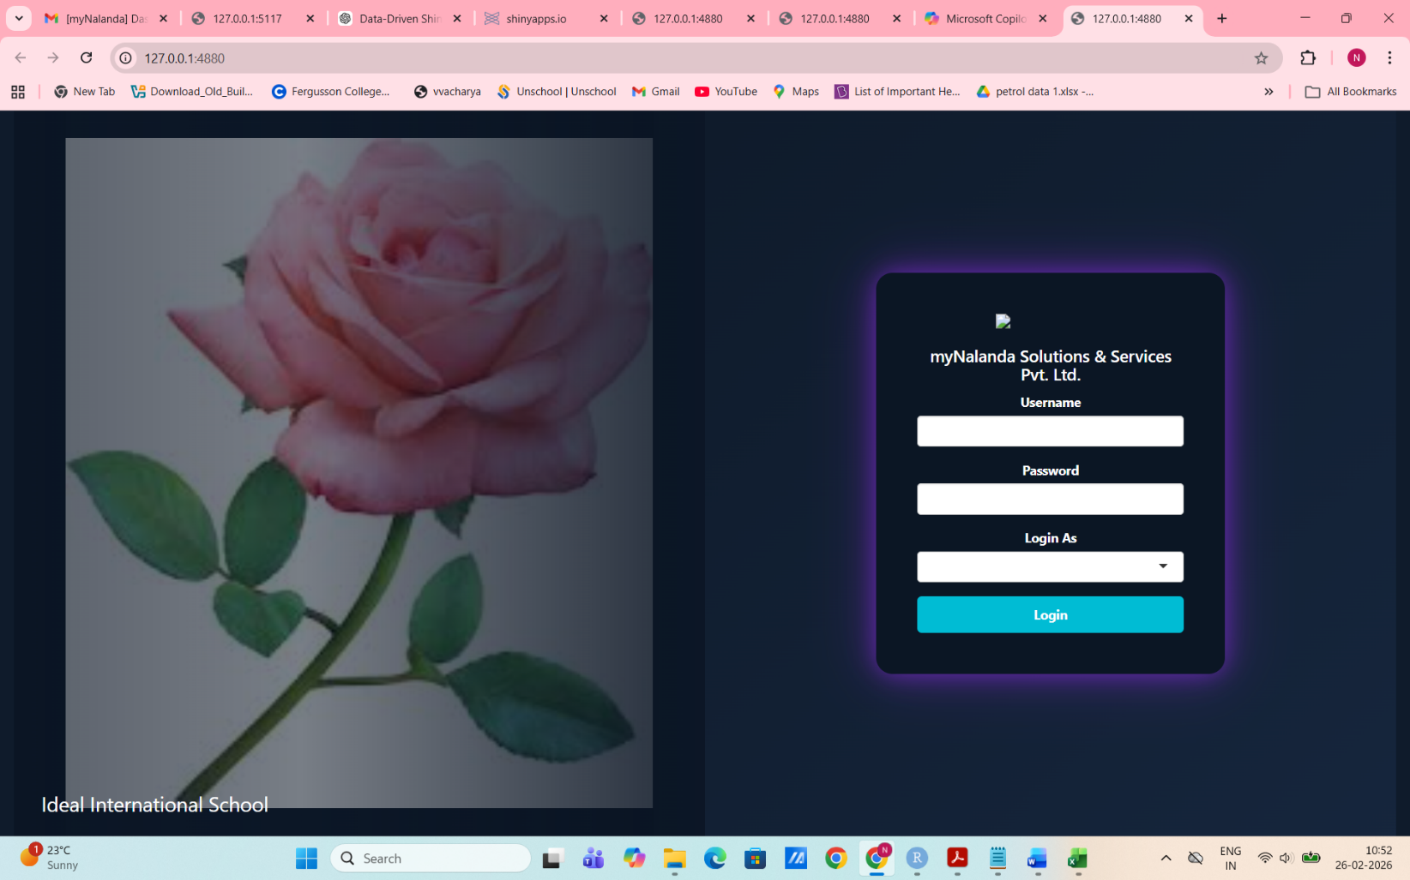
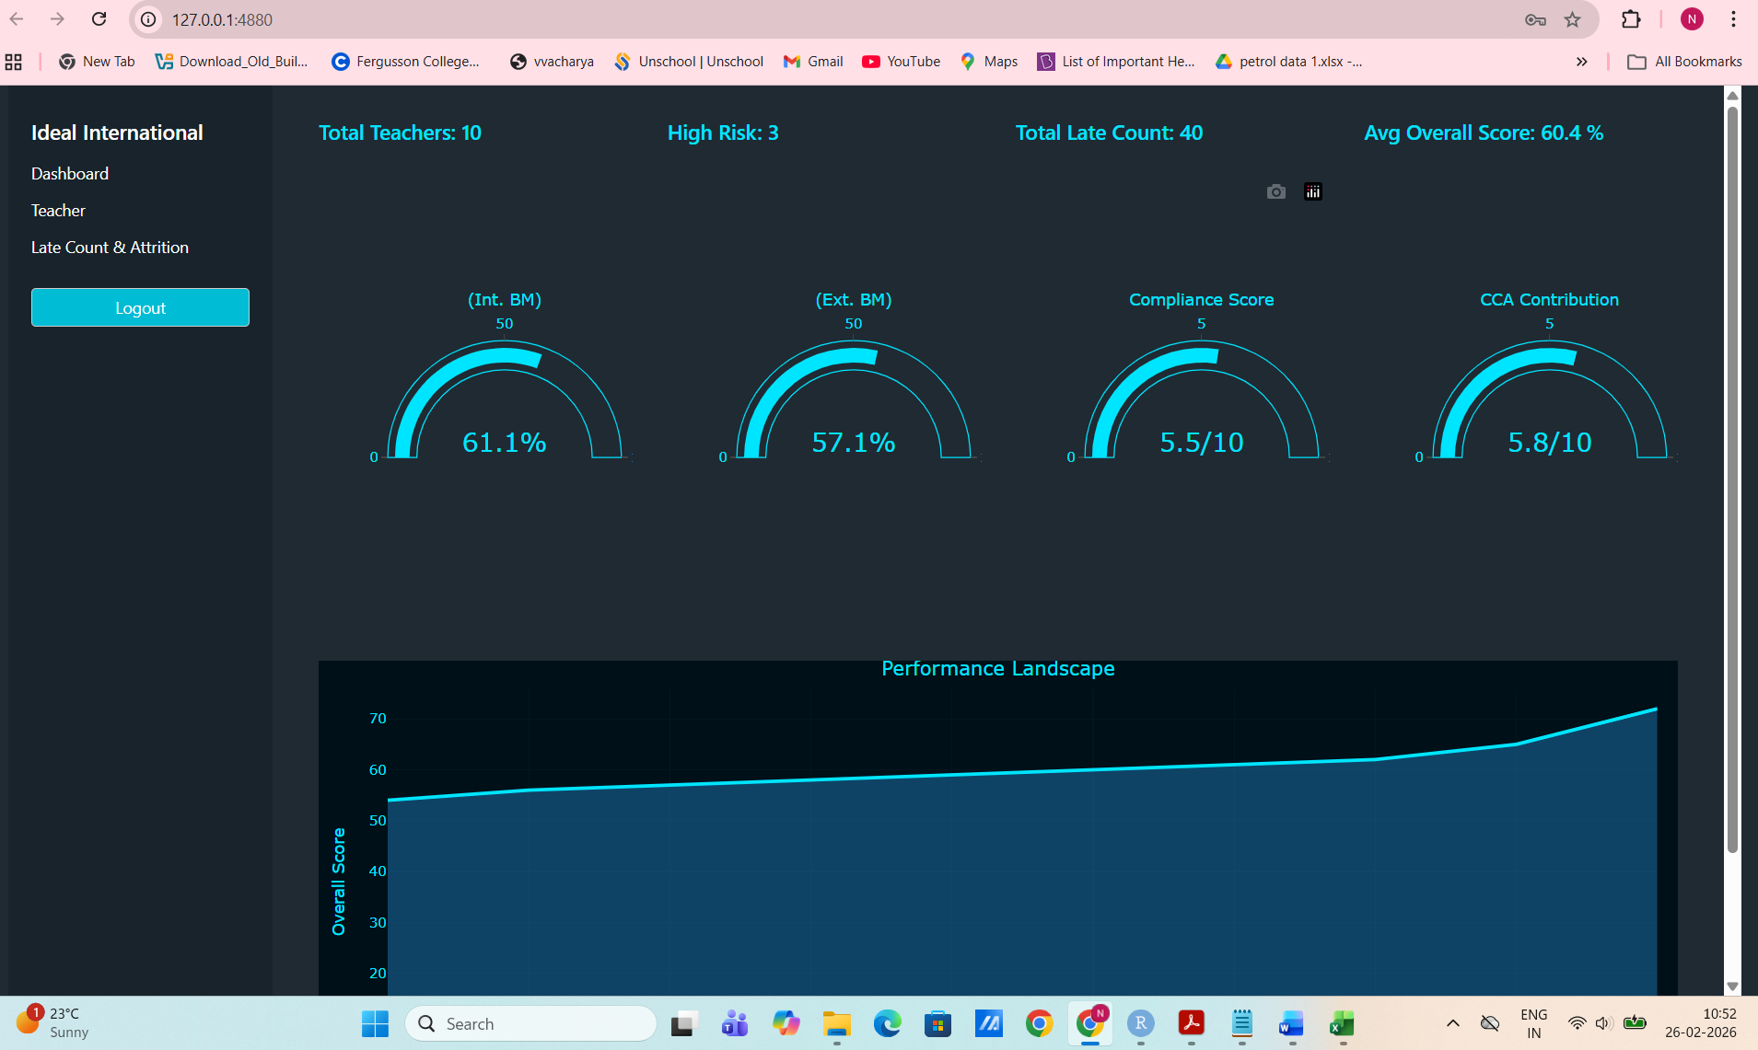

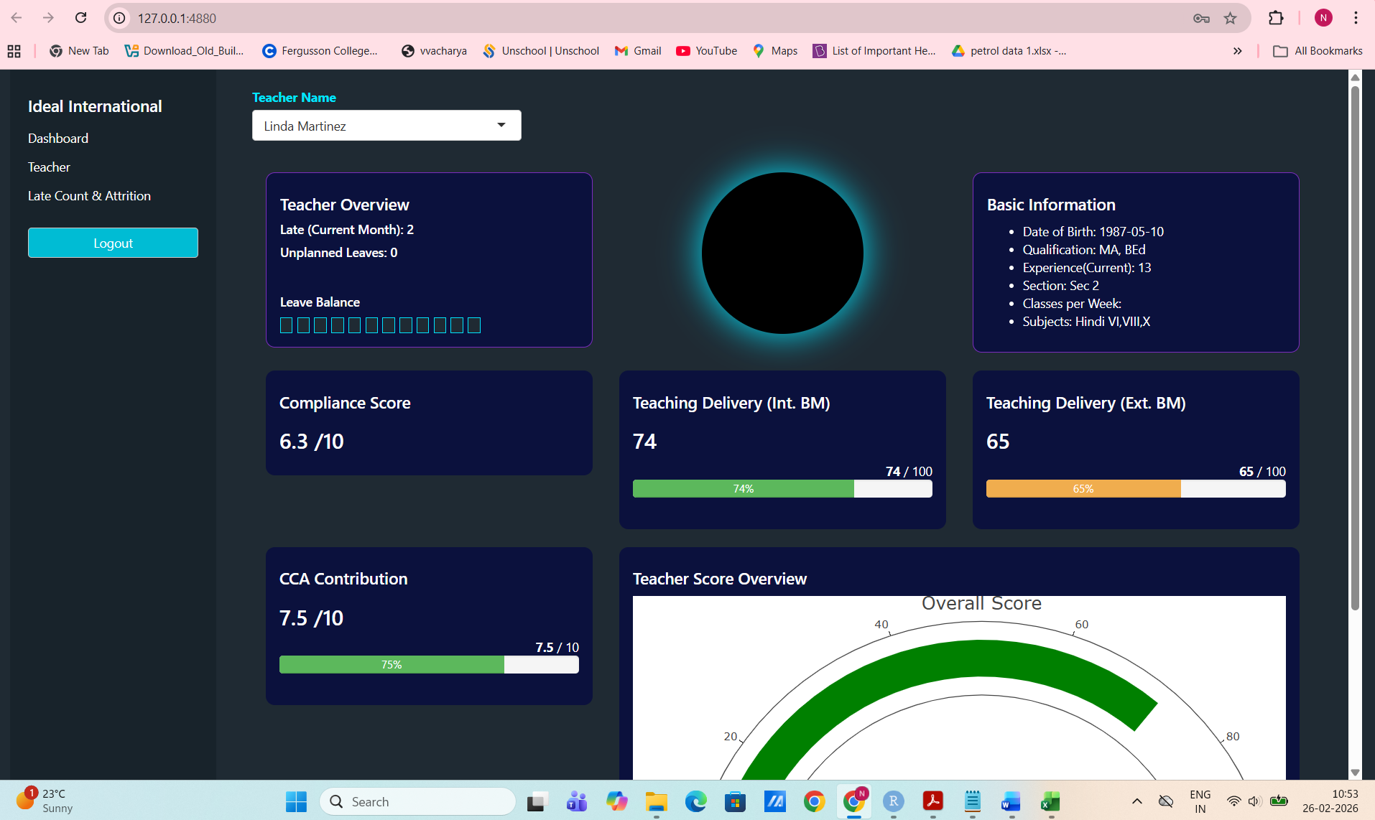
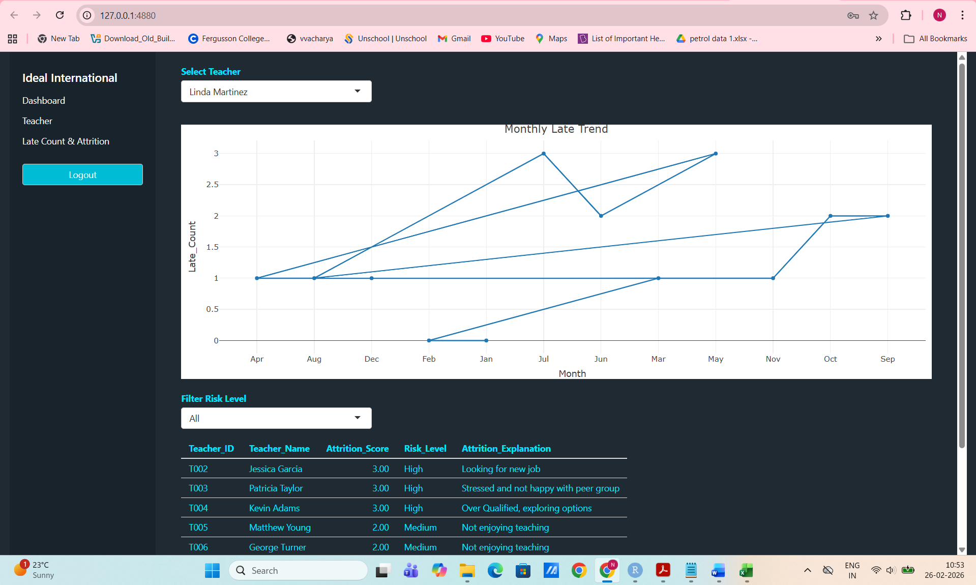

- Dashboard link :

- Insights:

- Teacher Workforce:
  - Total teachers: 10
  - High-risk teachers: 3
  - Total late count: 40 (indicates punctuality issues).
  - Average overall score: 57.7% ,That is, moderate performance level.
- Performance Benchmarks:
  - Internal Benchmark (Int. BM): 61.1%
  - External Benchmark (Ext. BM): 57.1%
  - Compliance Score: 5.5/10 That is, average standards.
  - Co-Curricular Contribution (CCA): 5.8/10 That is, average engagement.
- Trend: Performance landscape shows scores ranging between 20–70, with clustering around mid-range values. This suggests variability in teacher performance, with some excelling and others lagging.

Teacher-Level Insights (Linda Martinez)
- Attendance & Discipline:
  - Late count (current month): 2 ,That is, punctuality issue, though not severe.
  - Unplanned leaves: 0 ,That is, reliable attendance.
  - Leave balance: 10 days available.
- Performance Scores:
  - Compliance Score: 6.3/10 , That is, slightly above school average.
  - Teaching Delivery (Int. BM): 74% , That is, strong internal delivery.
  - Teaching Delivery (Ext. BM): 65% , That is, weaker external evaluation, especially in assessment design.
  - CCA Contribution: 7.5/10 , That is, strong involvement in co-curricular activities.
  - Overall Score: ~70% (above school average).
- Basic Information:
  - Experienced teacher (13 years).
  - Qualified with MA, BEd.
  - Teaches Hindi across multiple grades (VI, VIII, X).
  - Section: Sec 2.
Attrition & Risk Insights
- High-Risk Teachers:
  - Jessica Garcia → actively looking for a new job.
  - Patricia Taylor → stressed, unhappy with peer group.
  - Kevin Adams → overqualified, exploring other options.
- Medium-Risk Teachers:
  - Matthew Young & George Turner ,That is, dissatisfaction with teaching role.
- Implication: 5 teachers show attrition signals, with 3 at high risk. Causes range from career mismatch to workplace dissatisfaction.
Key Takeaways
- School-wide challenge: Compliance and punctuality are weak points.
- Strengths: Some teachers (like Linda Martinez) demonstrate strong teaching delivery and co-curricular contributions.
- Risks: Attrition risk is concentrated among a few teachers, but reasons are varied (job search, stress, overqualification).
- Opportunity: Targeted interventions in compliance training, punctuality monitoring, and teacher well-being could improve overall performance and retention.

